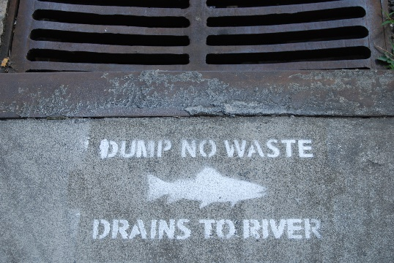

Storm Drain Marking Q&A
Your Name: Click or tap here to enter text.
Date: Click or tap to enter a date.

- Why is important that only water go down a storm drain?
☐The storm drain is not filtered and drains directly into the waterway
☐Rivers are the source of drinking water for humans and wildlife
☐Anything other than water in a storm drain can pollute a river and stream
☐All of the above

- A car leaking oil onto the street is what type of pollution?
☐Nonpoint Source
☐Point Source
☐Litter
☐None of the above

- Litter in a stream is what type of pollution?
☐Nonpoint Source
☐Point Source
☐Algae
☐None of the above

- While you are marking a storm drain, it is important to:
☐Hold the paint can far from the stencil and spray in a circular shape
☐Have only 1 person at the storm drain at a time
☐Wear your safety vest at all times
☐All of the above

- Why is protecting water important to you? Check all that apply.
☐I want to have clean drinking water
☐I want wildlife to be protected
☐I like fishing, boating and/or swimming in a clean lake or river
☐Other:
Click or tap here to enter text.

